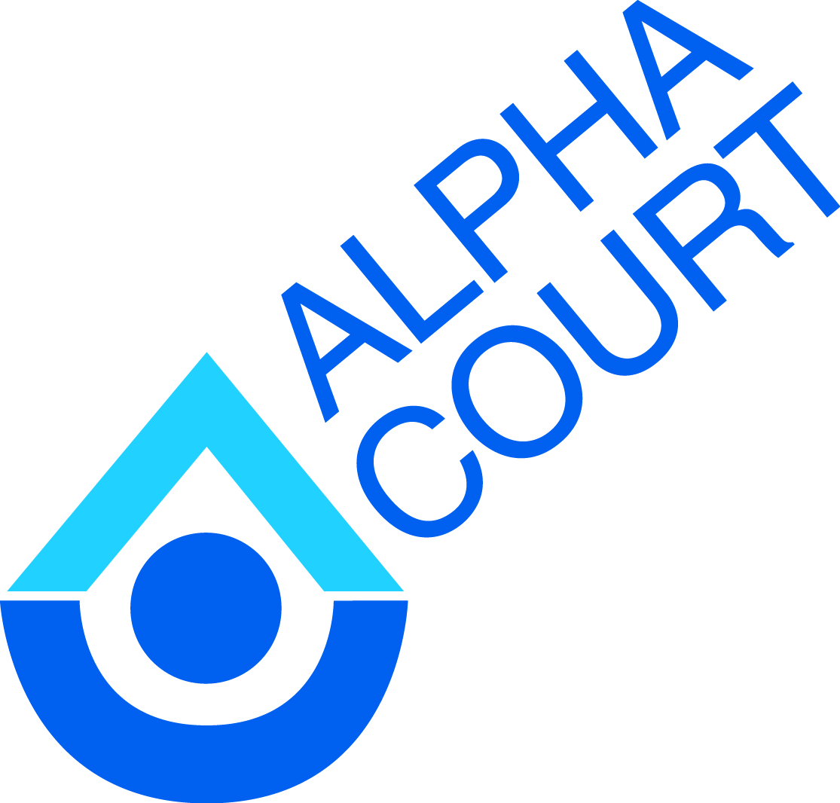

**Alpha Court**

***Community Mental Health and Addiction Services***

**Property Clerk *(Non-Union)*  
Full Time (36.25 per week) – 6 month contract with possibility of extension**

Alpha Court Community Mental Health and Addiction Services is looking for a Property Clerk.

Under the general direction of the Director of Property Management, the Property Clerk is responsible for the provision of property management services which include building and rent supplement programs.

**Qualifications:**

The ideal candidate will possess the following qualifications:

* Minimum of five years of property management. Experience in rent geared to income would be an asset;
* Experience working with vulnerable populations;
* Strong communication skills, including: verbal, written and listening;
* Knowledge of appropriate legislation including but not limited to the Landlord and Tenant Board Act, Residential Tenancies Act, Tenant Protection Act, Fire Codes, Building Codes and Human Rights legislation;
* Knowledgeable in the areas of word processing and Excel.
* Ability to multi-task and work in fluctuating environments.

**Submission deadline: September 1, 2017 at 4:30**

Please submit applications to:

Chantal Henderson, Administrative Assistant  
Alpha Court Community Mental Health and Addiction Services  
211 Wilson Street  
Thunder Bay, ON P7B1M7  
Fax: 683-8225  
Email: chenderson@alphacourt.ca

*Accommodations are available on request for candidates taking part in all aspects of the selection process.*