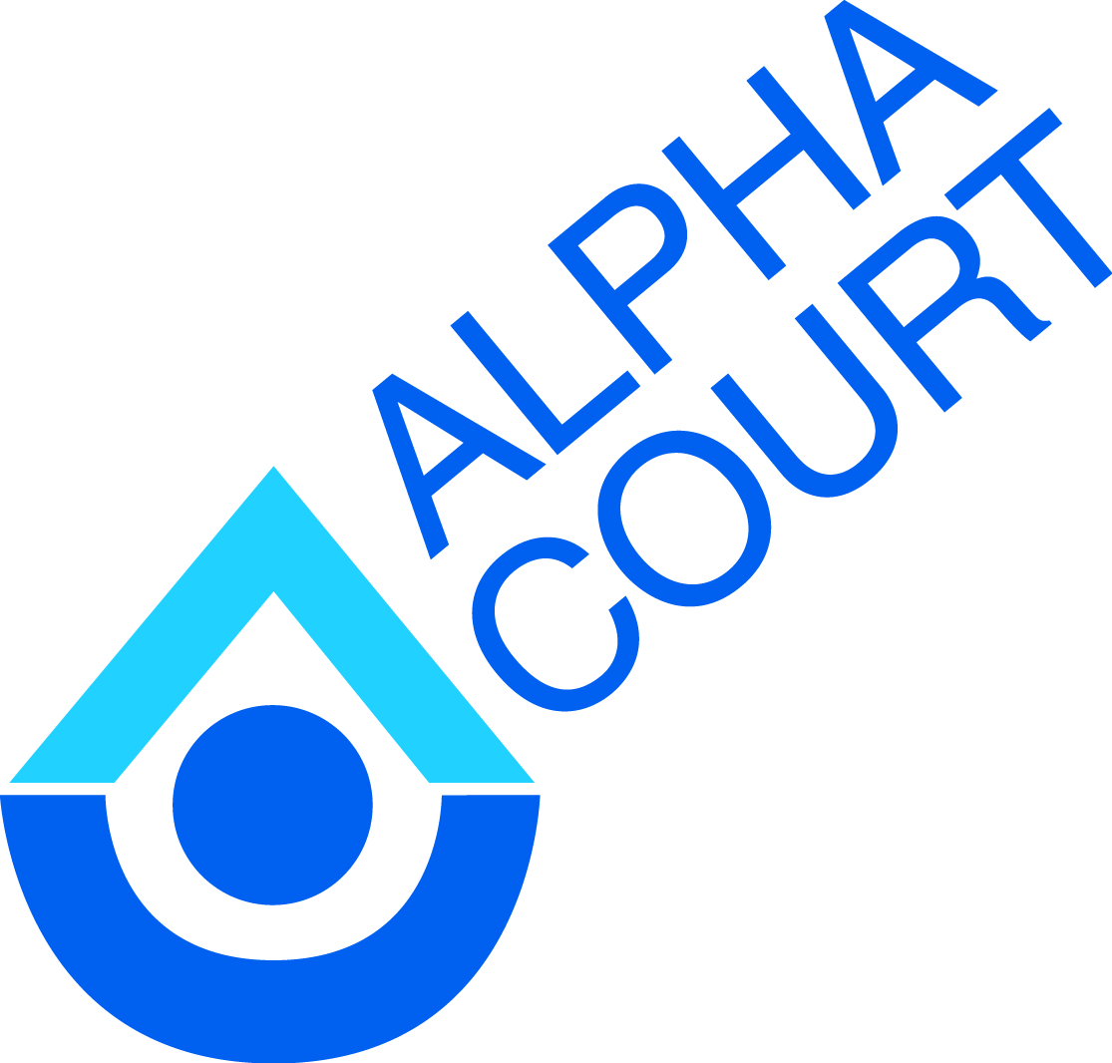

**Alpha Court**

***Community Mental Health and Addiction Services***

***External posting***

**Dual Diagnosis Case Manager**

**6 month Contract**

**$53, 147–$57, 147 (annually)**

Alpha Court Community Mental Health and Addiction Services is seeking a Dual Diagnosis Case Manager

Under the general direction of a Program Manager, the Case Manager is responsible for: assessments, comprehensive and individualized service plans, life skill enhancement, advocacy, promoting self-independence, referrals and collaboration with other service providers.

**Qualifications:**

The ideal candidate will possess the following qualifications:

* Degree / Diploma in Social Work, Health Care and Social Science;
* Relevant experience in mental health and the developmental sector;
* Experience with therapeutic modalities such as Motivational Interviewing;
* Experience developing and implementing individual service plans;
* Effective organization and time management skills;
* Strong written and verbal communication, planning and problem solving skills;
* Proficient with computers and related software.
* Membership with the OCSWSSW or another regulatory body is an asset.

**Conditions of Employment:**

* Completed Police Vulnerable Sector Check;
* Must have a valid Driver’s License, use of vehicle and appropriate insurance;
* Must be able to work a flexible week (36.25/week) to meet consumer and program needs.

**Closing Date: September 21st, 2018 at 4:30 p.m.**

**Please submit applications to:**

Maureen Colpitts

Alpha Court Community Mental Health and Addictions Services  
221 Wilson Street  
Thunder Bay, ON P7B 1M7  
Fax: 683-8225  
Email: mcolpitts@alphacourt.ca